**RESPONSI PRAKTIKUM SCPK**

NAMA : Shazi Awaludin

NIM : 123190123

PLUG : F

(Jum’at, 25 Juni 2021 – Sabtu, 26 Juni 2021)

Terlambat mengumpulkan karena izin sedang mendampingin ibu ke luar kota

1. **Weighted Product (WP)**
2. Link Github WP :
3. Langkah pembuatan program dan penjelasan

|  |
| --- |
|  |
|  |
|  |
|  |

1. Pembuktian (dibuktikan dengan perhitungan manual, 5 ranking teratas)

|  |  |  |
| --- | --- | --- |
| W | bobot | W(i)/Sum(W) |
| W1 | 3 | 0.230769 |
| W2 | 5 | 0.384615 |
| W3 | 4 | 0.307692 |
| W4 | 1 | 0.076923 |

|  |  |  |
| --- | --- | --- |
| S | rumus | Hasil |
| 21 | (4.5^-0.230769)  *(2275.877^0.384615)  *(3^0.307692)  *(29.3^- 0.307692) | 14.9431 |
| 6 | (7.1^-0.230769)  *(2175.03^0.384615)  *(3^0.307692)  *( 32.1^-0.307692) | 13.1256 |
| 14 | (20.4^-0.230769)  *(2469.645^0.384615)  *(4^0.307692)  *(23.8^- 0.307692) | 12.078 |
| 39 | (3.1^-0.230769)  *( 577.9615^0.384615)  *( 6^0.307692)  *(47.7^-0.307692) | 11.4602 |
| 17 | (1^-0.230769)  *( 292.9978^0.384615)  * (6^0.307692)  *(70.1^-0.307692) | 11.1236 |

|  |  |  |
| --- | --- | --- |
| V | rumus | S(i)/sum(S) |
| 21 | 14.9431/387.2297 | 0.03859 |
| 6 | 13.1256/387.2297 | 0.033896 |
| 14 | 12.078/387.2297 | 0.031191 |
| 39 | 11.4602/387.2297 | 0.029595 |
| 17 | 11.1236/387.2297 | 0.028726 |

1. **Simple Additive Wighting (SAW)**
2. Link Github SAW :
3. Langkah pembuatan program dan penjelasan:

|  |
| --- |
| Proses pengambilan data training dan label: |
| Penentuan mana cost mana keuntungan dan pemberian bobot tiap feature-nya |
| Retrieve (displaying) bobot yang diberikan |
| Normalisasi matriks training |
| Penghitungan value tiap baris data (perankingan)    Salah satu contoh hasilnya: |
| Pengurutan data dan feature dari index terbesar |
| Pengambilan list 20 rumah terbaik |
|  |

1. Screenshot GUI

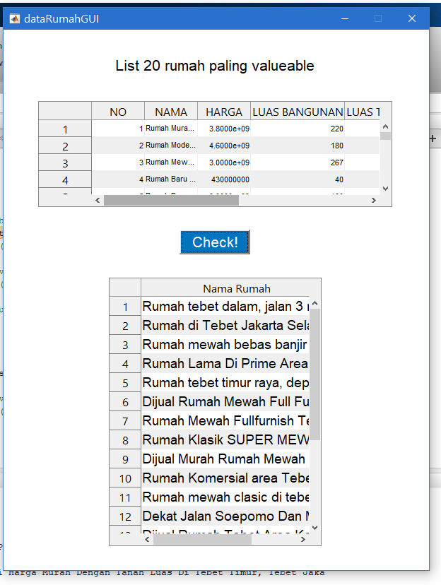

1. Pembuktian (dibuktikan dengan perhitungan manual, 5 ranking rumah teratas)

Harga = cost

LB, LT, KT,KM,GRS = keuntungan

Min(harga) = 430000000

Max(LB) = 1126

Max(LT) = 1400

Max(KT) = 10

Max(KM) = 10

Max(GRS) = 110

W = 0.3000 0.2000 0.2300 0.1000 0.0700 0.1000

Normalisasi:

|  |  |
| --- | --- |
| Harga | R harga |
| 35000000000 | 0.012285714 |
| 25000000000 | 0.0172 |
| 15000000000 | 0.028666667 |
| 55000000000 | 0.007818182 |
| 25900000000 | 0.016602317 |

|  |  |
| --- | --- |
| LB | R LB |
| 1000 | 0.888099 |
| 600 | 0.53286 |
| 800 | 0.71048 |
| 1126 | 1 |
| 600 | 0.53286 |

|  |  |
| --- | --- |
| LT | R LT |
| 1400 | 1 |
| 1000 | 0.714286 |
| 1225 | 0.875 |
| 1224 | 0.874286 |
| 1039 | 0.742143 |

|  |  |
| --- | --- |
| KT | R KT |
| 10 | 1 |
| 10 | 1 |
| 6 | 0.6 |
| 4 | 0.4 |
| 7 | 0.7 |

|  |  |
| --- | --- |
| KM | R KM |
| 7 | 0.7 |
| 10 | 1 |
| 9 | 0.9 |
| 4 | 0.4 |
| 5 | 0.5 |

|  |  |
| --- | --- |
| GRS | R GRS |
| 7 | 0.7 |
| 10 | 1 |
| 2 | 0.2 |
| 2 | 0.2 |
| 10 | 1 |

|  |  |
| --- | --- |
| Nama rumah | sum(weight.*R(i,:)) |
| Rumah tebet dalam, jalan 3 mobil, lingkungan tenang, nego | 0.630306 |
| Rumah di Tebet Jakarta Selatan | 0.546018 |
| Rumah mewah bebas banjir murah di tebet, Tebet, Jakarta Selatan | 0.494946 |
| Rumah Lama Di Prime Area Tebet, Komersial | 0.491431 |
| Rumah tebet timur raya, depan taman tebet | 0.487245 |